ML Model Deployment on Azure Services (AKS, ACI and Azure Function)

Table of Contents
Overview 3
Prerequisites 3
Enable Managed Identity Access for the target environment (Azure Function/AKS/ACI): 3
Set-up Access control: 3
Azure Functions 3
Independent solution: Deploy multiple models to Azure Function 3
Set-up Azure Function: 3
Deploy ML Models to Azure function (Independent solution) 4
Deploy ML Models to Azure function 5
Deployment to ACI 5
Independent solution: Deploy models to Azure Container Instance 5
Set-up ACI: 5
Configure User Managed Identity 6
Deploy ML models to ACI: 6
Deployment to AKS 6
Independent solution: Deploy to AKS service using YAML file 6
Code and script configuration 6
Setup and deployment steps 7
Azure ML dependent solution: Register and deploy model to AKS endpoint 7
Code and script configuration 7
Setup and deployment steps 8

Overview
The document provides the steps to setting up ML Ops scoring pipeline code and deploying to Azure Functions, ACI and AKS endpoints. Deployments can be dependent or independent of Azure Machine Learning platform, also code can be used to containerize ML models and save in Azure Container registry
These ML Ops pipelines can also be used to redeploy trained models or extended for other environments or onboarding new models.

Prerequisites
- User configuring and executing the pipeline for flowing access
  - Valid Microsoft Azure Account
  - Build Administrator
  - Contributor access to Azure Resources hosting the components (AKS, Azure Function, AML or ACI)
  - Contributor access on ACR for creating and storing image

- ACR should be configured and available to use.
- Storage Account – Blob storage to containing the input data for prediction

Enable Managed Identity Access for the target environment (Azure Function/AKS/ACI):
Enable Managed Identity access for the resources
Navigate to Azure Function à Identity à System Assigned à Turn “ON” the status
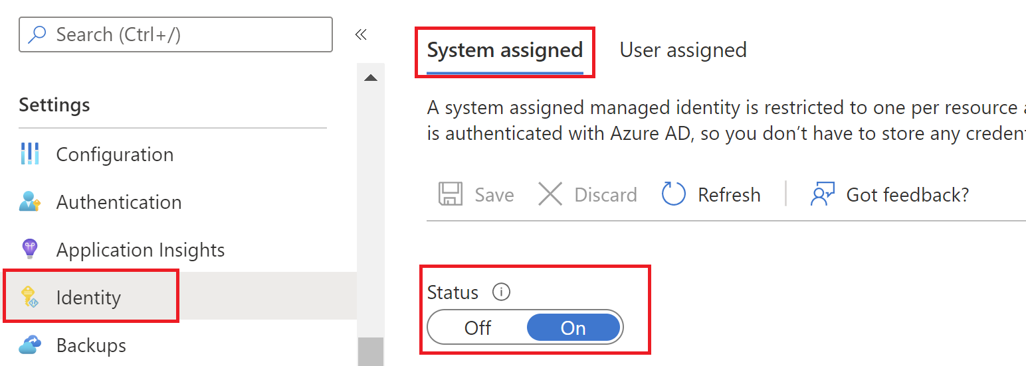

Set-up Access control:

Configure access between resources as per below details:
Source resource | Target resource | Access | Description
Azure Function/ AKS / ACI | Storage Account | Storage Blob Data contributor | To read the files for scoring
Azure Function/ AKS / ACI | Azure Container Registry | ACR Pull | To download the image for deployment

Azure Functions

Independent solution: Deploy multiple models to Azure Function

Set-up Azure Function:
- Create an Azure Function App
- Set up the configuration settings to connect to input blob storage:
- Login to Azure portal and navigate to Azure function
- Follow the below steps to create the configuration settings:
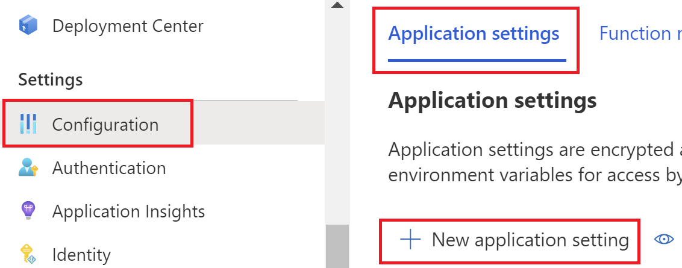Navigate to Azure Function à Configuration à New application settings.

Settings Name | Setting Value | Comments
adlsSTORAGE__blobServiceUri | https://<storage account name>.blob.core.windows.net
adlsSTORAGE__queueServiceUri | https://<storage account name>.queue.core.windows.net | Needed to access storage account using Managed Identity
adls_storage_account | <storage account name>
BLOB_PATH | <container name>/raw/<operating year>
FUNCTIONS_EXTENSION_VERSION | ~3 | Validate Azure Function version
DOCKER_REGISTRY_SERVER_URL | https://<Azure Container Registry URL> | Navigate to Azure Container Registry à Access keys à copy Login server name.
DOCKER_REGISTRY_SERVER_USERNAME | <Azure Container Registry Username> | Update ACR Username
DOCKER_REGISTRY_SERVER_PASSWORD | <Azure Container Registry Password> | Update ACR Password

Note: BLOB_PATH variable contains the path of the Raw input data file in ADLS storage container.

Deploy ML Models to Azure function (Independent solution)
- Copy code from “AzureFunction/Independent Solution”
- Place ML model in “AzureFunction/Independent Solution/model” folder
- Run setup.sh script present in “AzureFunction/Independent Solution/scripts/” with model name and function type as parameters.
bash setup.sh -m <model name> -t <function type >
Note: This will setup the function which will be deployed on to function app by copying all required information from function template folder. The function will get created under “src/func_ap” schema.

- Run the builddocker.sh script present in “AzureFunction/Independent Solution/scripts/” with ACR directory path as parameters.
Command:
bash buildDocker.sh -a <ACR Server Name> -r <ACR Repository Name >
Note: This will build the docker images for the new onboarding models and push the image into ACR
- Once the above script is executed successfully, a new docker image gets created under the ACR Repository as mentioned in previous step.

Deploy ML Models to Azure function
- Navigate to the Azure Function app Deployment Center Settings
- Populate the Registry settings with appropriate options:
Settings | Comments
Container Type | Select Single Container from drop down menu
Registry Source | Select Azure container Registry from drop down menu
Subscription ID | Select appropriate subscription ID from drop down menu
Credentials | Select Admin Credential Option
Registry | Select appropriate Registry Name from drop down menu
Image | Select appropriate Image Name from drop down menu
Tag | Select appropriate image tag from drop down menu
Continuous Deployment | Enable Continuous deployment by selection “On” Option

- Once all the required fields are populated with appropriate information, click on “Save”.
- Navigate to Logs to check the status of deployment, it will take same time to pull the docker image from the ACR and deploy the same into azure function app.

Deployment to ACI

Independent solution: Deploy models to Azure Container Instance

Set-up ACI:
- Update settings in configuration files: The configuration settings for ACI should set in config.cfg file present in “ACI/scripts/configuration” folder as shown below:

Provide the below details in the config files:
Parameters | Comments
acrname | Provide the ACR name from which the docker images needs to be pulled.
acrrepo | Provide the ACR Repo name which contains all the latest docker images.
aciname | Provide the ACI name which needs to be created and setup.
regname | Provide Resource Group name in which ACI needs to be setup.
acimsi | Provide the user managed identity name which needs to be created and which would further be associated with ACR and ACI.

Configure User Managed Identity
- Once the above parameters are provided in the config file. Run the below command in the bash terminal by setting the execution path of the terminal to “ACI/scripts/”:
bash setup_msi.sh

Once this command runs successfully, a user managed identity will get created which will have “acrpull” access in the Azure container registry.
- Provide “Storage Blob Data contributor” access to the same user managed identity inside the Blob Storage Account so that it can read/write data from the storage containers.

Deploy ML models to ACI:
Run the below mentioned script in the bash terminal by setting the execution path of the terminal to “ACI/scripts/”:
bash deployToACI.sh

The above script executes the below mentioned processes:
- A new docker image of the ML model will be created and pushed to the Azure Container Registry.
- A new Azure container instance is created, and the same User managed Identity is assigned, which is created in the configuration step.
- The User Managed Identity helps to pull the latest image from ACR and deploys the same into ACI.

Deployment to AKS

Independent solution: Deploy to AKS service using YAML file

Code and script configuration
- Download folder AKS -> Independent Solution
Sample source code structure:
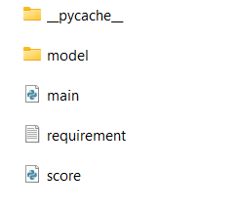
- Place model to be deployed in “src” folder and update scoring script accordingly
- Update requirements.txt as per the libraries needed by models

Setup and deployment steps
- Setup docker file, update code paths in Dockerfile
Build docker image for the solution using “buildDocker.sh” in scripts folder, ensure Dockerfile is present in the root folder for the solution to be deployed
bash buildDocker.sh -a <ACR Server Name> -r <ACR Repository Name >
Note: This will build the docker images for the new onboarding models and push the image into ACR
- Update the deployment.yaml
Placeholders | Description
deployment-name | Name of deployment/workload in AKS
acr-name
sacr-repo-name | ACR repository name
image-tag | Tag of the image to be deployed, timestamp generated in dockerbuild file (Step #1)

- Run deployment script from “script” folder
bash deployToAKS.sh -s "<<subscription id>>" -r "<<resource group name>>" -a "<<aks cluster name>>" -n "<<deployment name>>" -c "<<deployment config file name>>"

- Check pod status and code will be deployed on the target pod
Note: Current code deploys code to pod and with timer it will execute scoring script to download data, run scoring and upload results to blob storage.
You can modify the main script to convert it into an API or run the code using CRON jobs, this section will be updated in upcoming releases

Azure ML dependent solution: Register and deploy model to AKS endpoint

Code and script configuration
- Download folder AKS -> AML Dependent
Sample source code structure:
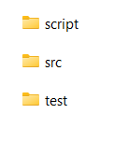
- Place model to be deployed in “src” folder and update scoring script accordingly
- Update requirements.txt as per the libraries needed by models

Setup and deployment steps

- Setup configuration file (config.yaml) in “src” folder
Placeholders | Description
subscription_id | Azure subscription ID
resource_group | Azure Resource group
deploymentendpointname | Azure ML endpoint name
modelname | Name of model to be deployed
environmentname | AML environment used to setup AKS endpoint
entryScriptname | Scoring script name
akscluster | AKS cluster name
amlworkspace | AML workspace name
source_directory | Path of the directory where code is located, in this case same folder

- Run deployment script from “script” folder
bash deployToAKS.sh

- Check deployment and pod status in Azure ML -> Endpoints tab
To test AKS endpoint -> refer to script in “test” folder, replace the path of service endpoint to ping and check if the service is running.
Note: To view AKS endpoint logs, you might need to do Azure authentication, there will be a passcode generated in logs, use that for authentication

